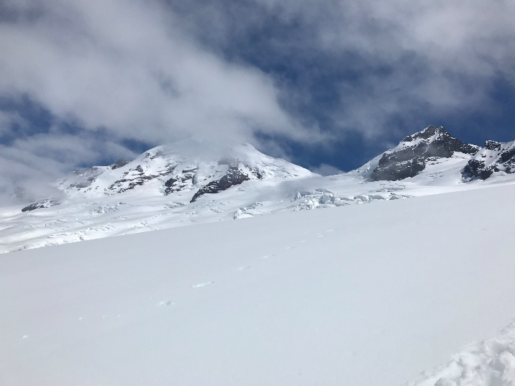
Mt Baker Attempt; 2018 June 15 PDF LINK
Matt Squires, Julia (Squires) Templin, David Blair, Steve Marquis
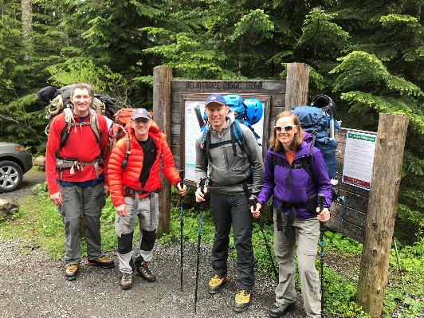
I have to say with all the work and relocation and just life troubles like almost all my joints screaming at me! To deem myself fit enough to join these fine friends was a great blessing. Rarely then when Matt and Julie drove up 5am Friday, I was all but waiting on the curb, packed and anxious to hit the trail.
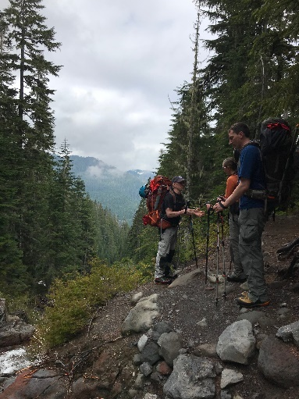
We dovetailed with David in Duval and in his larger car made a comfortable 2 ½ hour drive to the ranger’s and then the bumpy dirt road to the trail head. The weather was a bit cloudy and made for a perfect coolness to make the trudge to high camp. It’s a gorgeous trail that after a few miles suddenly busts out of the tree-line to present the full glory of the Colman Glacier cradling the fully exposed Grants’ Peak, the formal name of Mt. Baker’s summit mount.
Our conversation was delightful and meaningful dabbling in all forms of forbidden fruit of polite conversation! Our bodies all seemed to be in full capacity and the mountain gave easily before of steady effort; while the generally shaded sun mercifully withheld its more intense displeasures as we pushed more earnestly up the snow dome to high camp.
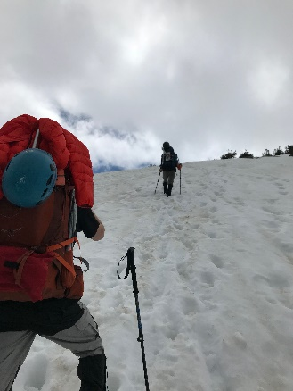
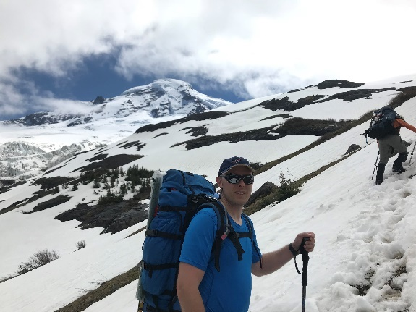
Several other teams were gathered at the treeline and I could hear and observe teaching of newbees as teems roped up. I was not as inclined to rope up here as I had never seen crevasses this low, but that was soon to be disproved. We moved out in single file behind me and to my surprise but a few hundred feet up the hill I encountered the 1st of several smaller crevasses – but still large enough to warrant caution and generally roped travel. I criticized myself for not being able to see that farther in advance. Going to have to get my ground penetrating radar adjusted!
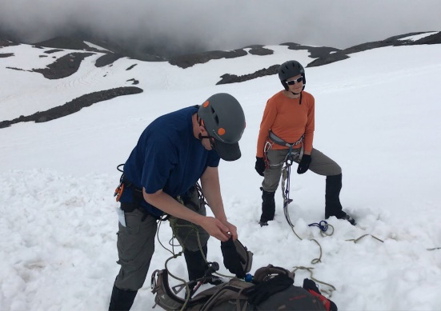
As we roped up, much to my competitive chagrin, a few of the teams we had passed earlier now passed us! As we followed the rolls I kept thinking and saying as we passed flags placed by an earlier team, possibly the rangers, that this will be the last flag and then we will be at the plateau high camp, but nooooo, one more flag, and then another…and another but finally my belated prediction was vindicated and we spilled out onto the almost flat high camp. Now the sun was in full beam and the mountain peak shone and fairly smiled at our insignificance; clouds whisped and whirled about at the top; occasionally obscuring the top but generally portending an increasingly clear summit- our timing was perfect! or so it seemed.
Roping_up_Movie_link
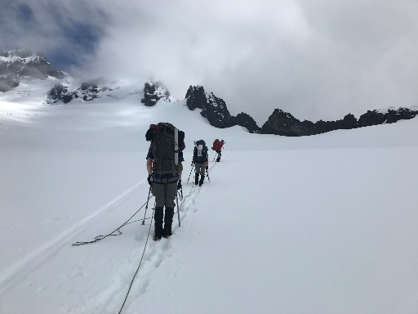
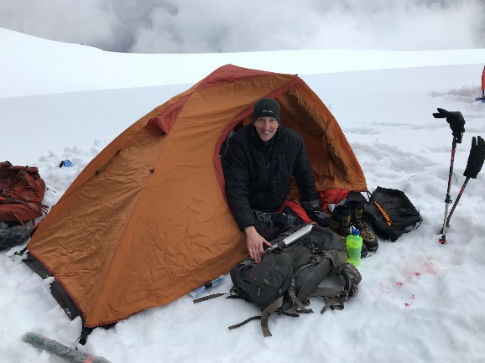
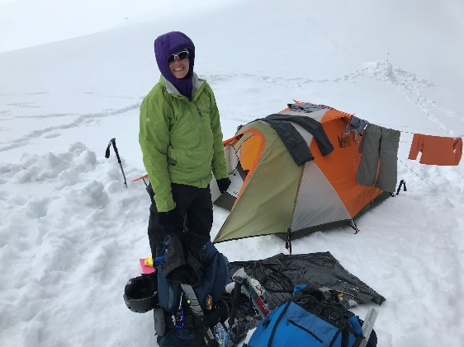
At high camp, we snuggled right close but out of reach of falling boulders from the Black Buttes; though finding a fist sized stone near our tents caused us to debate, just how safely out of reach of the Black buttes endless decay we really were. Another small group of young 20s boys came near and we invited them to plant their tents near us. They were …young men having a good time, but generally fine neighbors.
By mid/late afternoon, after choking down some of the worst freeze dried I dare say REI ever offered, the wind began to pick up and battered us as more and more as clouds gathered on our destination. Hmmm Still with good spirits and a group prayer, we retired (~9pm)
Suzanne’s harp music alarm rudely jostled me from my more meaningful of the 2hr cat naps that passed for sleep. Ugh 4am - Hard to believe we do that at midnight for Rainier! It had been brutally windy all night and I was …OK but cool. I was not the only one that felt the night pass slowly and coolly. Julia was also just on the wrong side of comfortable.
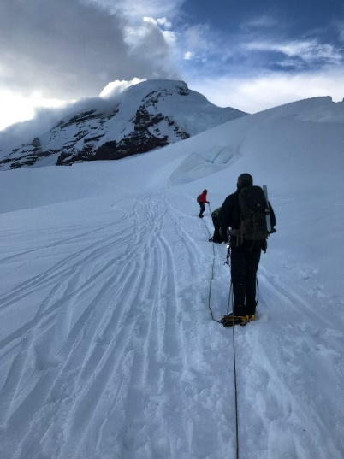
The wind was not even close to showing mercy and I donned all my gear including goggles; a rarity for me. Twilight was upon us for the last couple hours. I noticed the light easily before 3AM. We had no need for lights. Then with a bite of frozen protein bar for energy and a gulp of fluid, I took lead position on the rope with Julia , then David and finally Matt as anchor man. Trudge is the perfect descriptor of what transpired next and for several hours. The peak looked accessible at 1st but as the few hours ticked by an angry cloud gathered and hid the peak and held it tightly from view.
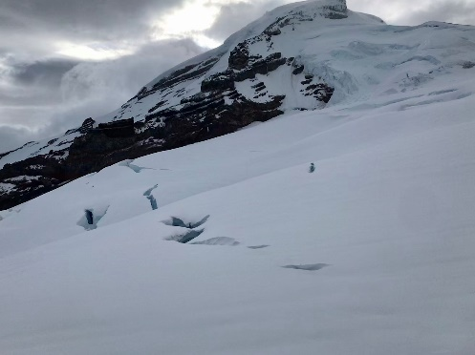
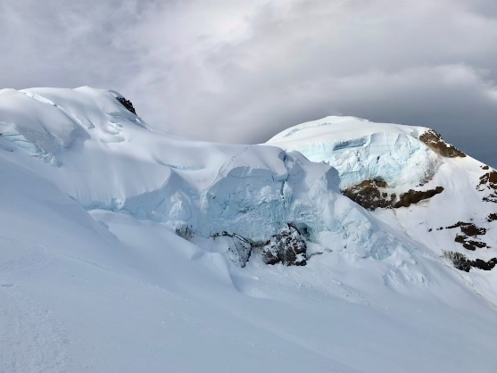
After a few hours though at one stop, Matt was having stomach issues again – but this time at much lower altitude. He barfed a bit and dry heaved at the smallest hint of food; even a jelly bean was too much. I began to suspect something other than Altitude, but maybe more exertion & the super early hour were playing a negative role for him. We will want to get to the bottom of that as you definitely need some real energy outlay at this point. Still he was a real trouper and pressed on as fast certainly as I was interested in going – which was a “Steady gains the mountain” slow pace that I felt we all could sustain.
The bergschrund was easily negotiated this time and the final push to the Roman Wall was not really that steep- quite a change in actual terrain from my last summit of this peak. One thing I remembered from my 1st attempt was the massive wind at the Roman Wall. I remembered it because the mountain now was throwing all it had at us with easily 50 MPH ICE cloud winds buffeting us as we hunkered down around a small rock that I had hoped would have afforded a bit of protection – not even! We were now up on the famous Roman wall’s rock band and I needed to assess our new move.
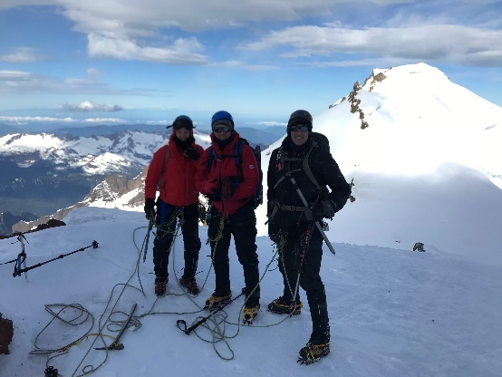
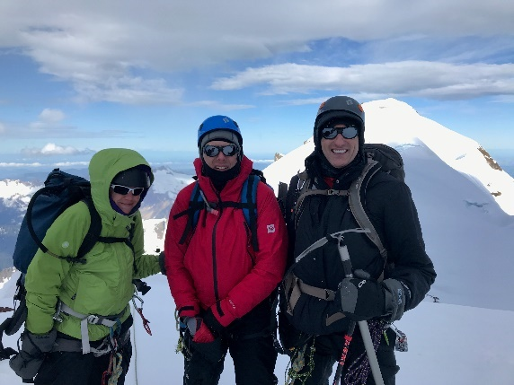
The view below was spectacular, but the view above was a dense fiercely blowing cloud of ice! By now I could not feel my fingers in these new glove mittens I was trying and that was not good if I needed to help anybody - let alone myself. Matt was feeling no better, The summit was tantalizingly close but our most significant push was yet before us with no likelihood of any visibility whatsoever at the top. I asked the group for their feelings; consensus was easily obtained that this was High (enough) on the Mountain and we were grateful for that. My tradition was to sing the hymn, “High on a Mountain Top” and all joined in for a rousing rendition. My Norwegian Mission companion Ned Bjorn used to say, “Laugh at the Cold’ We turned our back to the summit and set our sights back to high camp and made quite good time with gravity more our friend than former enemy.

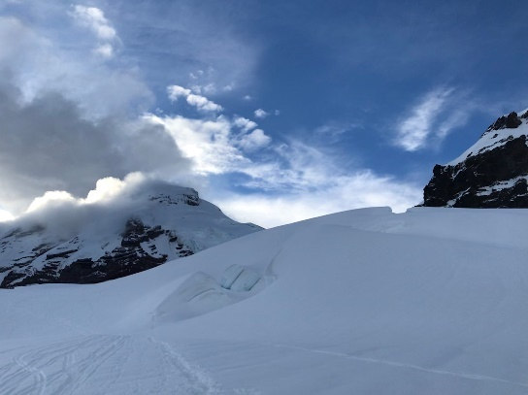
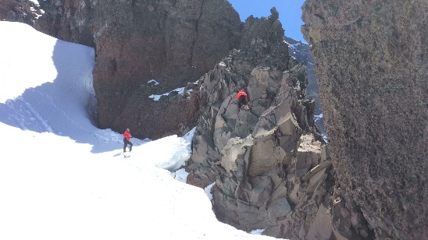
Matt belayed me when we got back to camp up the Butte's knife edge so I could see the other side. The Brekke formation was a crumbly mess and almost all holds felt “portable” and I felt just a bit more dangerous than I am wont to feel. Julia wanted more Ice Axe instruction so the steep snow right at camp was the perfect spot. While we played, Dave and Matt practiced the crevasse rescue scheme using a Z-pully. The air was practically still now and the sun gently warmed us but we could see the angry cloud on the peak still held tight; gripping the summit despite being ripped by the fierce winds.

Julia Sliding Movie Link Julia Slomo Movie Link Matt&David_Z-pully Movie Link Steve Arrest Practice Movie Link Steve&Matt_RockClimbing Movie Link
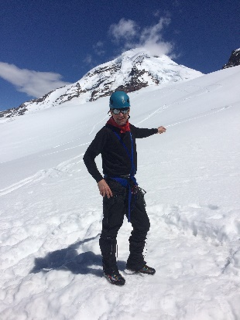
A few folks after us did get to the top that day but not with much or any view. This pic shows one of the few tantalizing moments when the peak popped its head out to tease us once more. For us now in the lower reaches of high country, It was peaceful and visually glorious.
Packing was a sloppy hasty affair as we shoved and stuffed with far less care. I had learned my lesson and when asked about the rope said we would use it as long as we were on the glacier. That’s the right answer and I know it, but there is still that boyish part of me who sometimes thinks he’s above all that…but I did the right thing by my team and together we rapidly descended and one point in the flats running echelon style down a steep crevasse free section then back to single file. After the rolling section of many flags and passing what I thought was the last of the several crevasses a steep section begged for a butte glissade, and roped we all slid together. One fellow we stopped to talk with for a moment opined he had never seen that and we briefly mused over whether the rope helped or guaranteed the whole team plopped into the crevasse. Obviously, I was counting on the former!
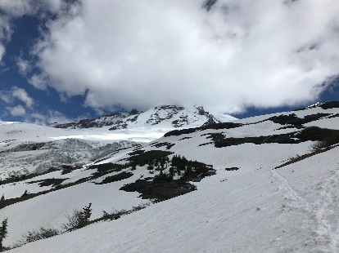
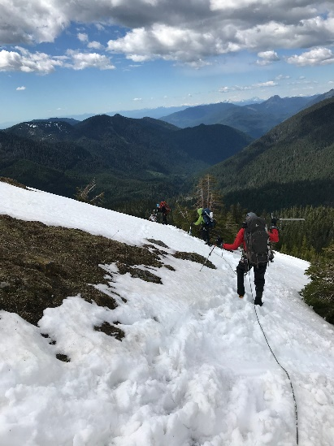
Off we went again and slid and whooped it up, then quite suddenly a smallish (2-3’ across) crevasse I had not seen/anticipated was right before me. In an instant I determined ‘JUMP’ was the right solution – which I did by leaning forward and with my legs boosting me along with my momentum across the gap. I yelled “Crevasse” and the words – “Jump it” I slid a bit farther then quickly stood with rope in hand to help Julia in case she did not jump. – She did not jump, but with a mighty tug and her momentum and a swath of snow plowing into the gap, she easily popped to my side. We both slid down a bit farther until Dave approached it. Again I yelled to “Jump it”, but he did not jump, rather plowing another yard of sticky snow into the gap and sailed over it too. Lastly, Matt plowed through it too; now more of a whoopdedoo than an obvious crevasse.
Wow! That was a thrill – more one I’d like to avoid. That’s a scenario I’ll have to add to my topics to discuss and practice. I’m sure with all our other practice that if I had yelled, “Crevasse, Arrest,” we would have all stopped, but jumping – that was never a topic of discussion!
It turns out we had drifted off the centerline we had climbed and that is why I had not seen this additional tail of a crevasse. I was grateful for the prayers and a good rope team that would have been prepared to anchor and help each other.
We slid all the way down to the tree line and with a fast-strong pace made the couple mile trek to the cars crossing the large stream, this time flooded and more challenging. All our boots served us well with no blisters this time – Super! Two sets of jumper cables to reach our car’s dead battery from some kind neighbors and off we went – great stories, lifted spirits and more than one of the world’s problems solved during our keen and friendly conversation!
God is Good and so were these great companions.
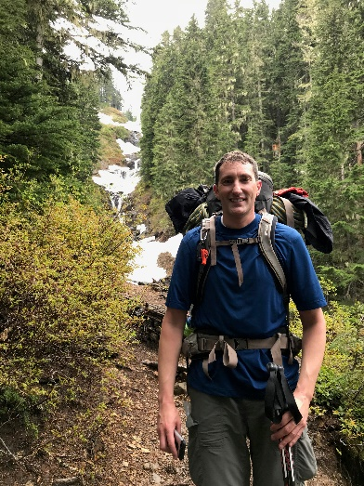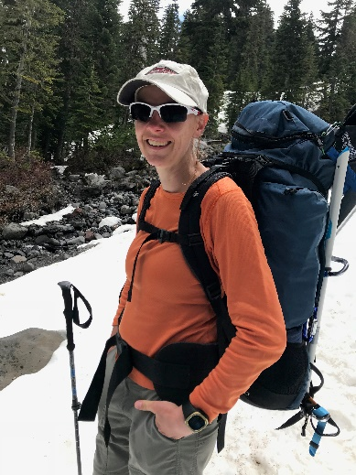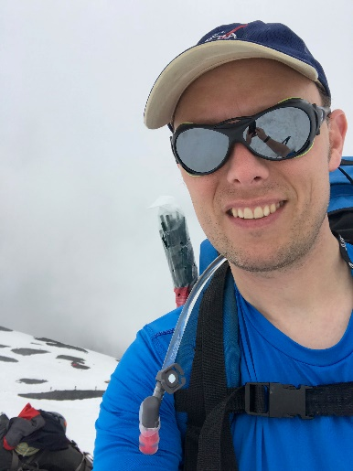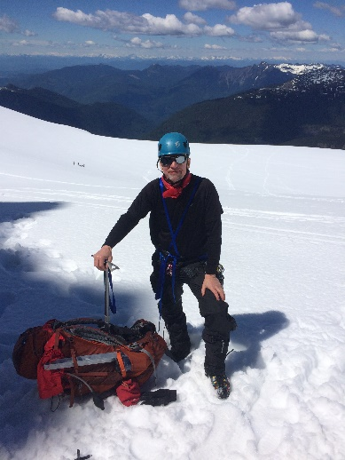
Steve

