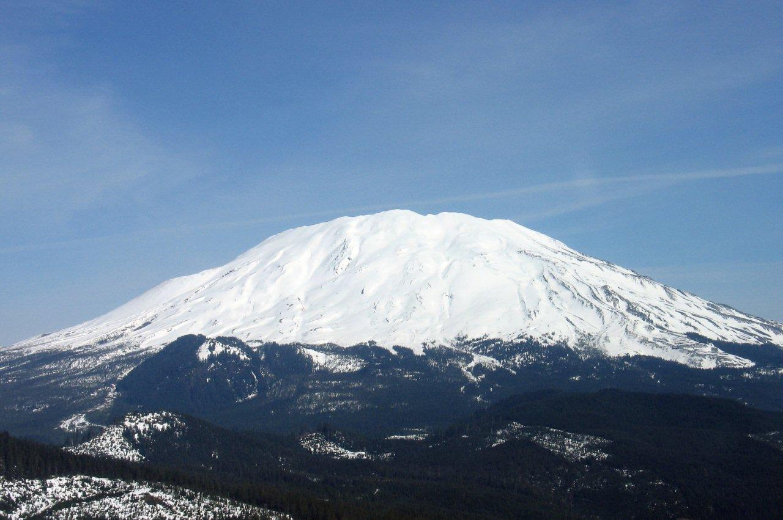Helens 2010 June 25th
Trevor Fisher, Glen White, Bishop Gordon, Tanner Paxman, Carlin Anderson, Blake Lytle, Derek White, Michael Flindt, Corey Anderson, Spencer Flindt. Brad Simpson, Darrell Paxman, Brad Nielsen, Kyle Flindt, Steve Marquis
Note: Click individual pictures for higher resolution
Journal Entry Helens 2010 June 25th

I was just requesting some sample parts from Brad Nielsen, an applications engineer for Texas Instruments when some clerical person who had been cc'd on this email thread added an unusual personal note, "Brad, don't get too close to that cornice!" Only a week ago an experienced climber gotten too close to the cornice at the crater rim of Mount Saint Helens and plunged to his eventual death. Making the connection, I casually mentioned that that mountain was on my to-do list. Immediately Brad fired back that due to a cancelation a free permit was available. Trouble was I'd have to be packed and insure arrival at their scoutmaster's house by 3pm today! At work and car-less - this would be trick. Still I jumped at the chance. My dear wife and son who happened to be staying with us this summer took loving care offering to pack my pack, pick me up and deliver me as needed. What a team!

It was a big push but I arrived at the little ranch just a few minutes late due to some roadwork but fortunately for me I wasn't the last. One of the scout leaders introduced himself and I mentioned my own affiliation with a troop. "Oh" he asked casually "and who is your sponsor?" "Mine's an LDS sponsored troop from Issaquah." "Well brother,” thrusting out his hand, “this is an LDS troop too and I am Bishop Gordon. What a pleasant surprise; I had only very casually known Brad but as the miles pealed on I found a real kindred soul.

Like Jeff on my Mount Adams climb, Brad is a critical thinking faith filled engineer and being LDS our dialog and inquiries freely explored nuances of our theology. He and our other companions were also staunch conservatives so I was definitely in my element and the miles flew by quickly. We arrived at near dark at the climber's bivouac; set up tents and then joined a fine campfire the camper guys had set up.

The conversation seemed to be in a bit of a lull so I asked if they'd like to hear some missions stories; they did and I shared a few funny and also a couple faith building ones to finish the campfire on a more spiritual note than my first story about walking on water.
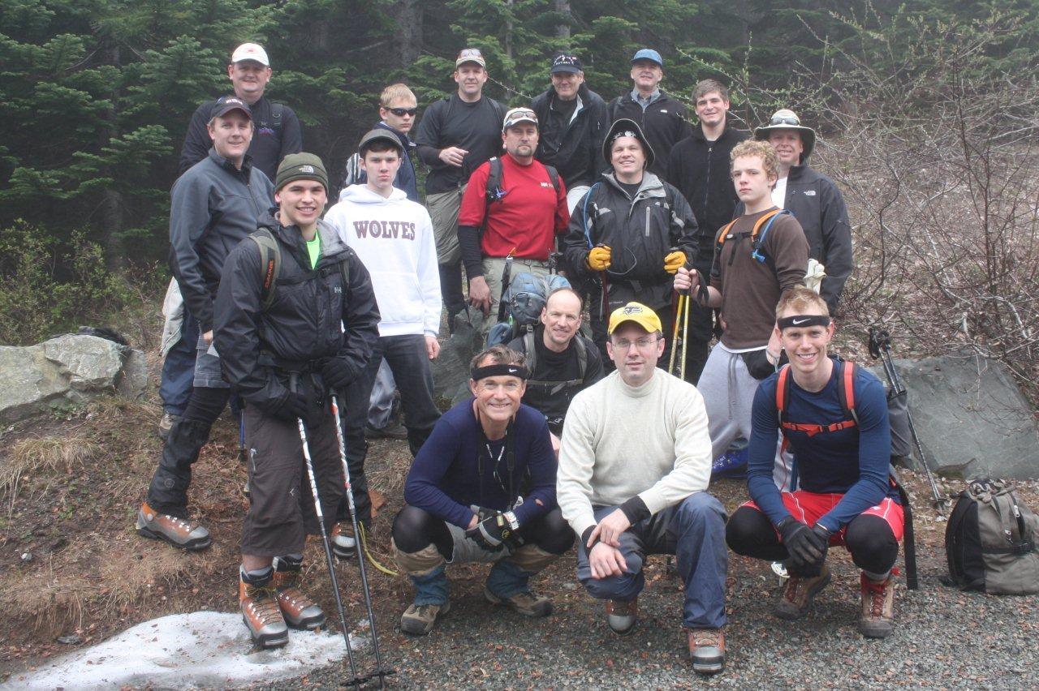

In the morning we all shared a common breakfast (thanks!) donned our small packs and headed up the snowy trail. Since I was training for Rainier, mine was not so small and looked a bit out of place since all the others stood with minuscule daypacks. I would have to work hard from beginning to end to stay up with them, but I felt up to the challenge. It was overcast for a good chunk of the morning as we climbed. That suited me fine as I was working very hard to keep the pace of my companions. As we worked our way up the forest to the tree line, the sun worked its magic and after a couple thousand feet we suddenly popped out to cloudless splendor.

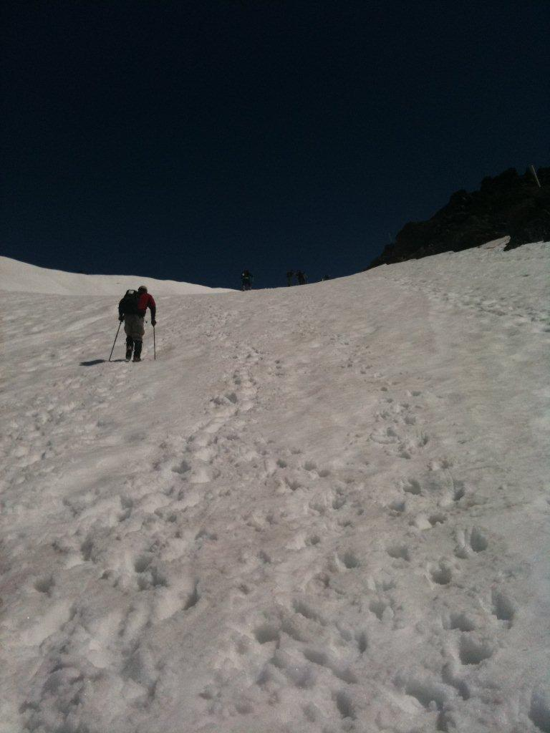
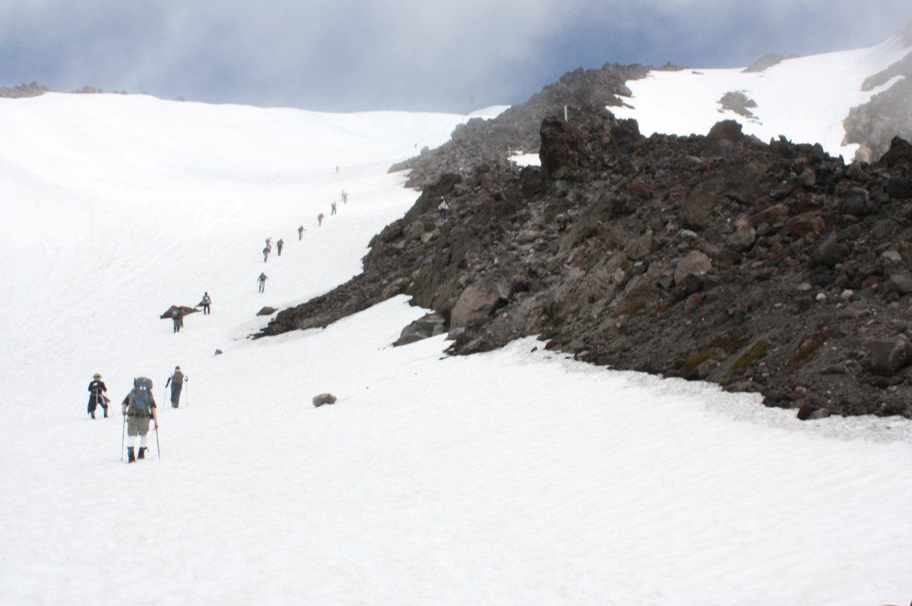
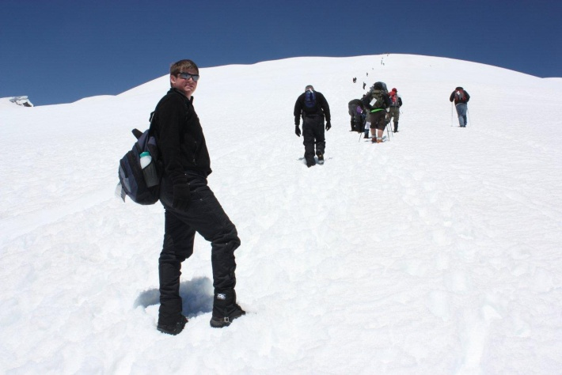
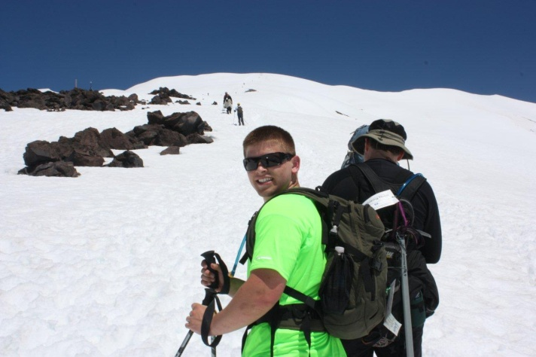
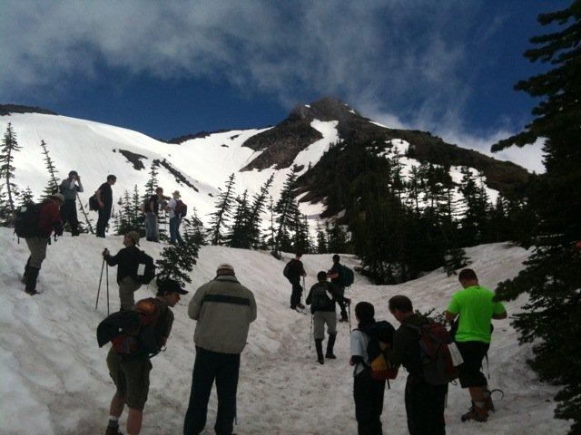
The group was pretty spread out coming through the trees but now gathered together. One of the adult leaders asked if we all wanted to stay together or go ‘every man for himself.’ I thought that was odd for a youth group and mused to myself how the priesthood principles would be served by ‘option B.’ They finally decided to just regroup periodically at key points and so off we went again. For the most part I climbed alone enjoying the comradery when I'd catch up. I was totally in my element chatting with other climbers we'd pass and snapping pictures here and there. I think my new friends might have wondered how I was faring with my heavier load as I tended to bring up the rear but I was keeping a steady good pace with my sightseeing and jabbering mostly responsible for the slight lag.

The snow would have been simply outstanding for skiing and as we neared the top of our 4000+ foot climb I imagined myself careening down one butt glissade after another.
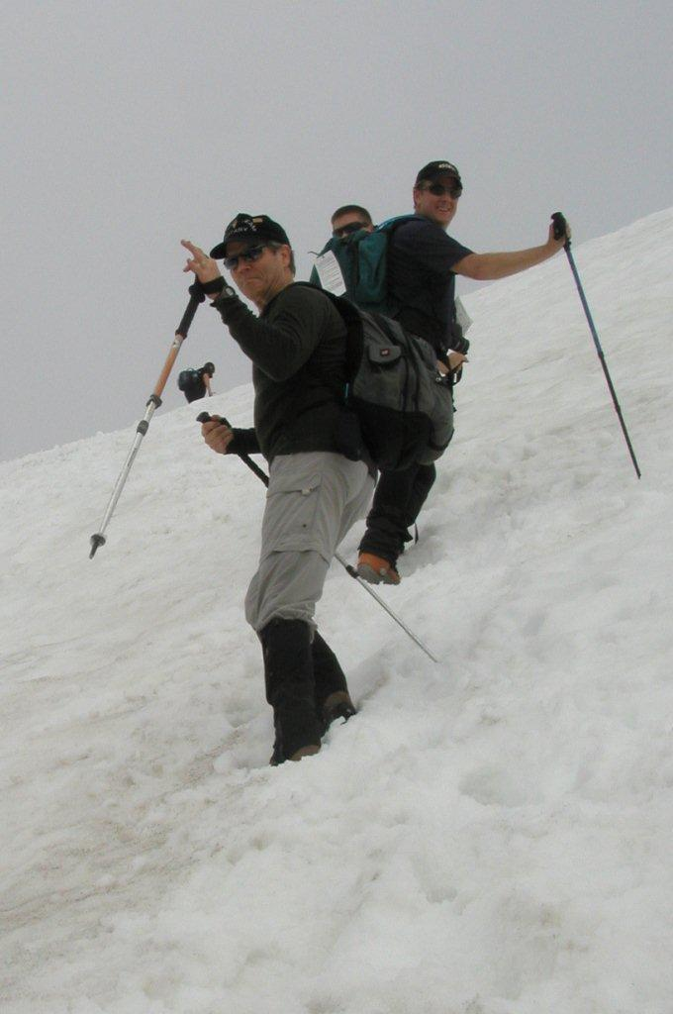
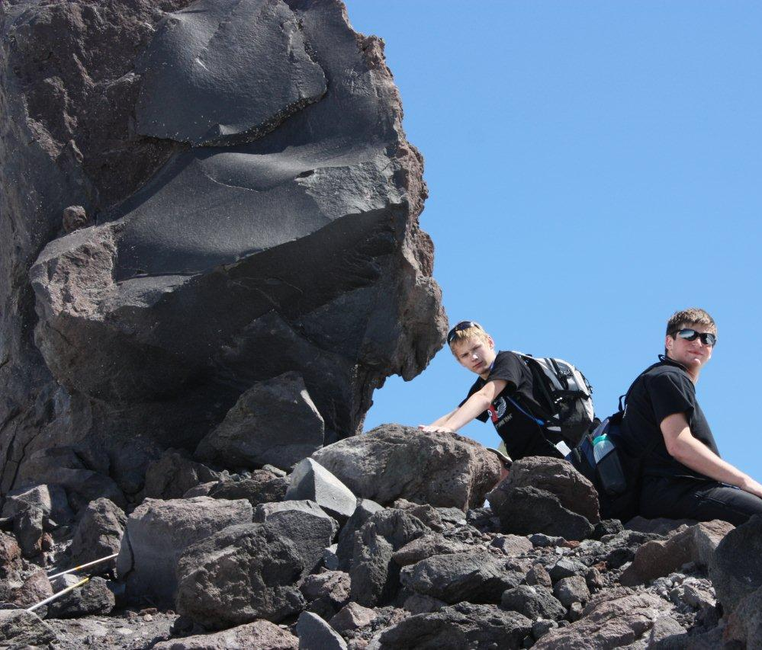
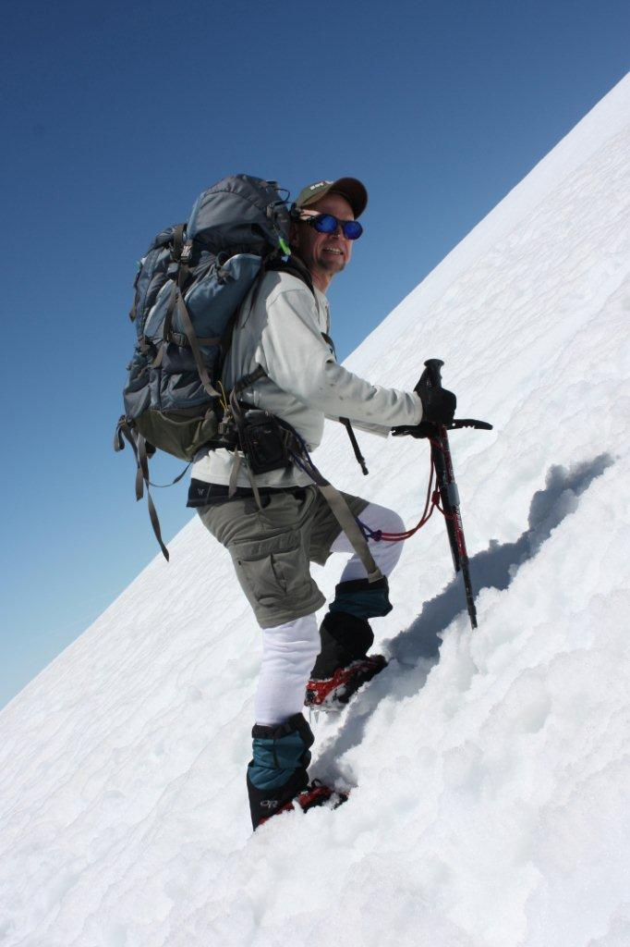

The wind picked up a bit as the crest came in view - only several hundred feet left to go now. I added a layer and donned gloves for the first time today. I departed this time in advance of the troop who were resting on a rock out cropping. It was crumbly rubble and pumice that must make for one tiring climb in the summer but with our very late snows this year the trail was heaven.

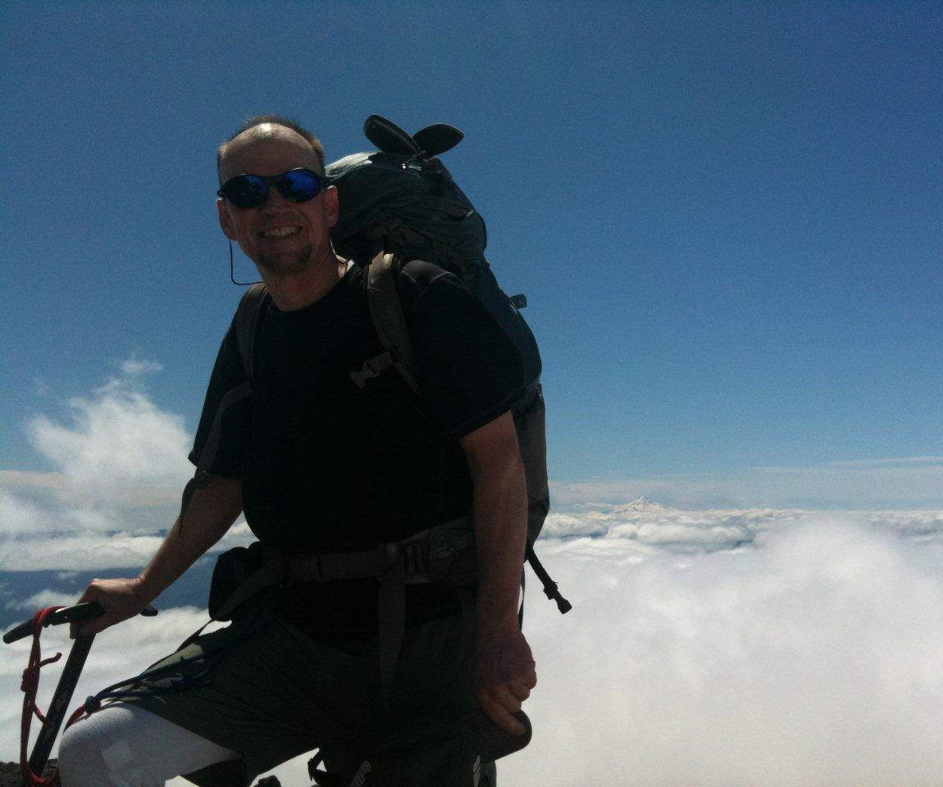
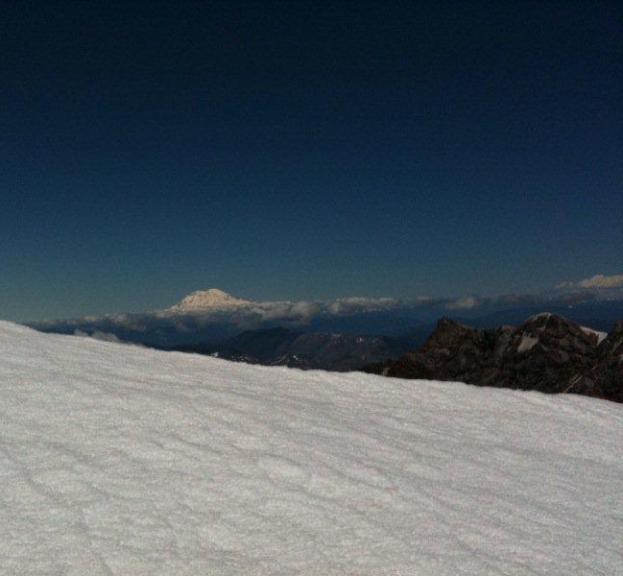
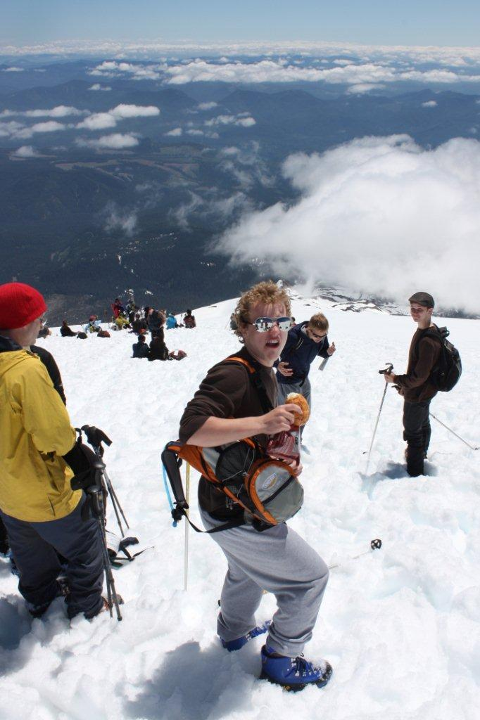
I could see a modest crowd dotting the skyline. We stopped shy of the crest for good reason knowing that that climber had died only a few weeks back near this very spot. Now that we were there, we faced the same dilemma; how close is too close. Where is the rock and where is the cornice. You could only just guess. We took a few pictures as close as we dared and then I suggested we ought to descend just a bit for our lunch. I was thinking the whole time about the conversation that that fated climber must have been having – just a little closer….
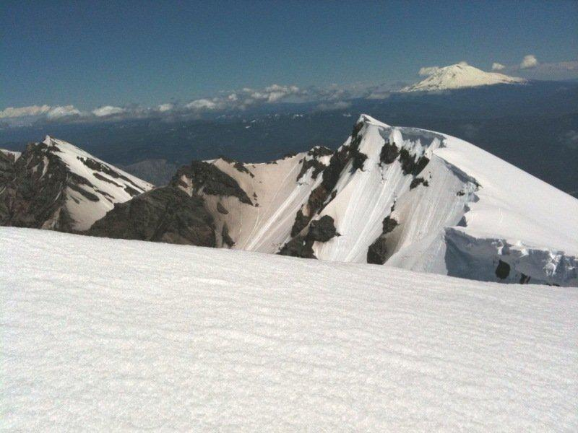

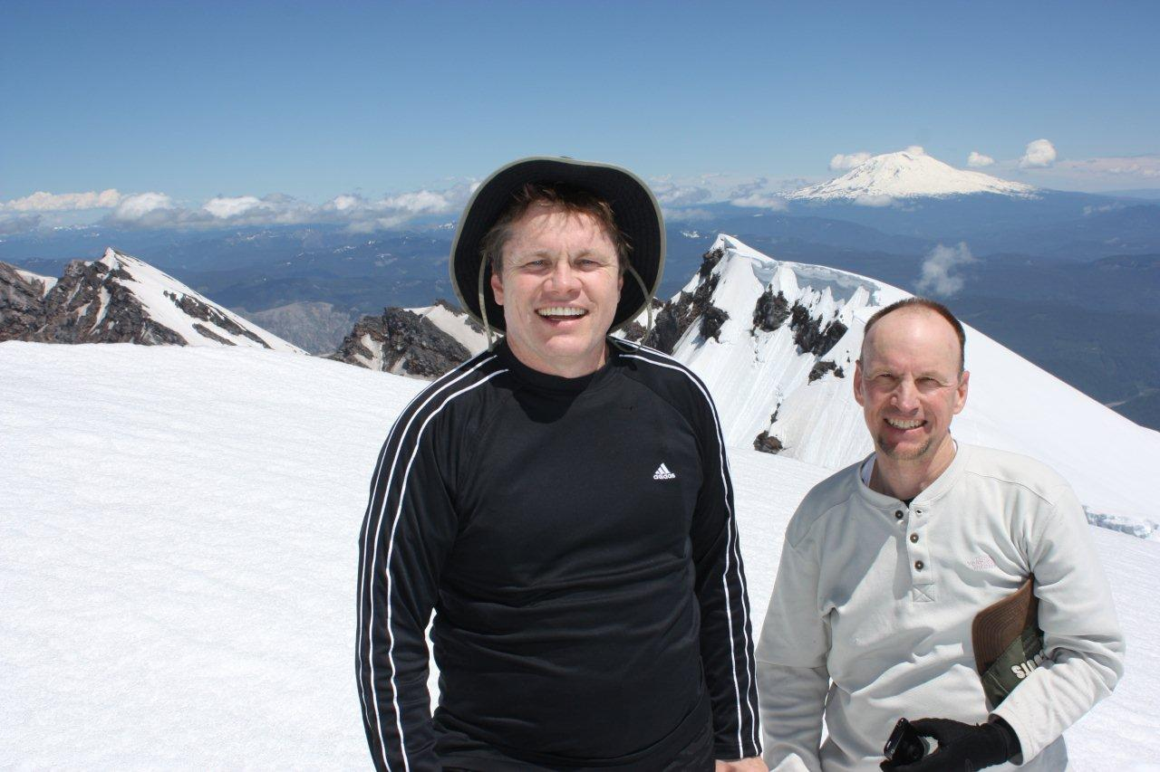There is something I like to do at the top of each mountain and I asked the bishop if I could solicit their participation. Asking the group which hymn was most appropriate for the moment someone guessed "High on the Mountain Top."
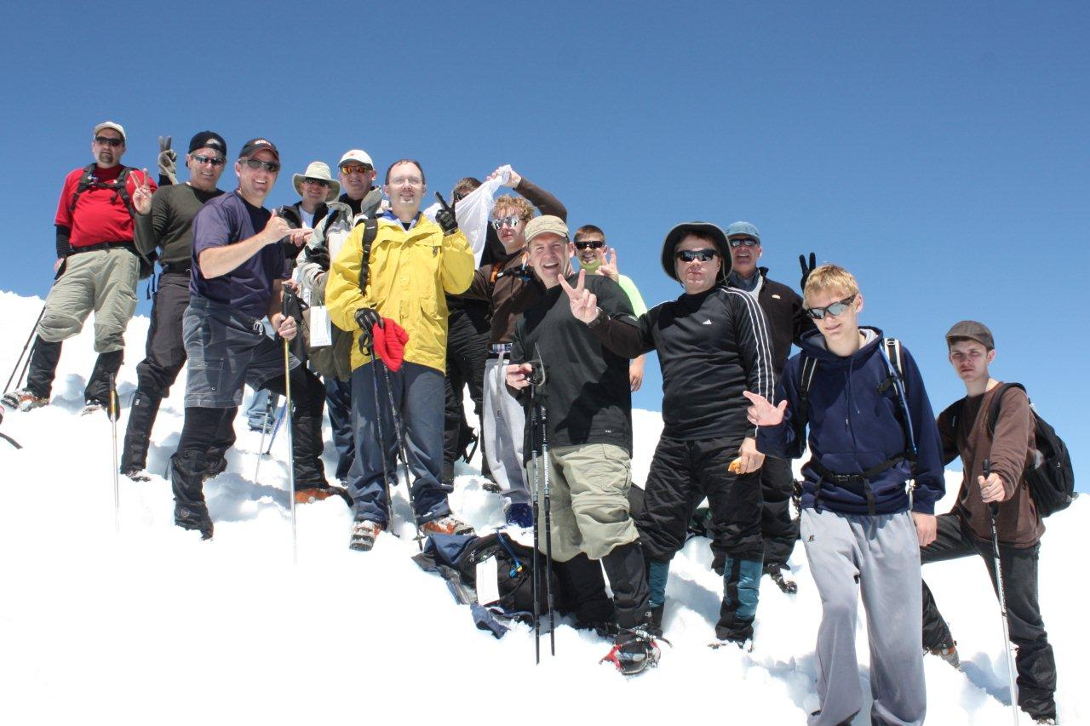
I began to sing it., then the bishop joined in and soon the entire hillside was blessed with our voices.

What followed were long stretches of great butt sliding.
Click here for Movie Clip
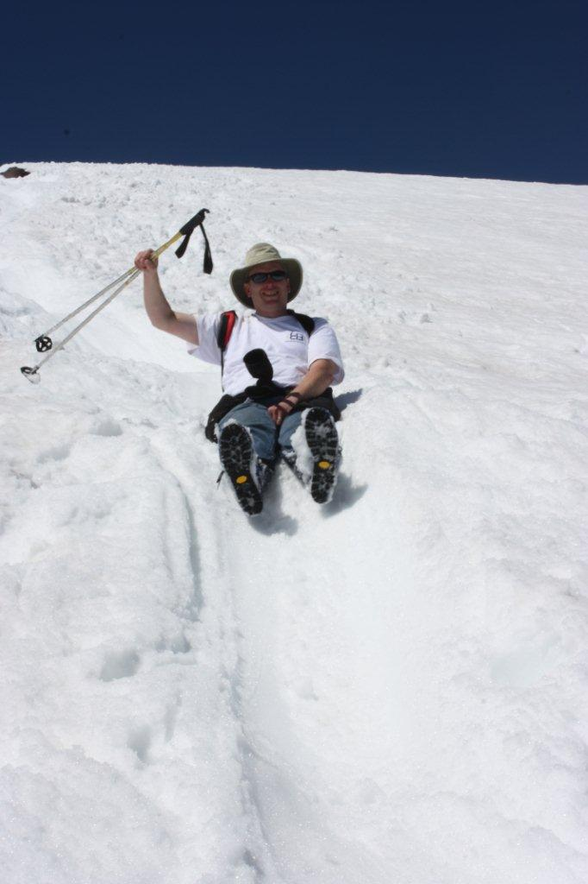
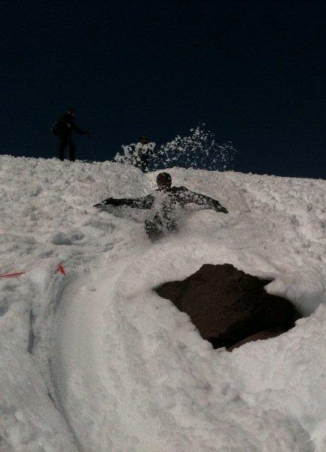
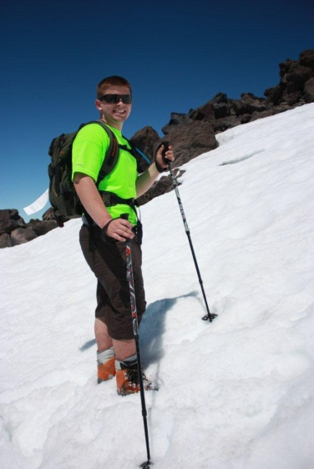
On the way down a few of us travelled together in some loose confederation and along the way close to the tree line we picked up another young man from our group who being entirely alone was feeling a bit lost. Very understandable and again I wondered why the leaders let the party get so strung out. Never one to lose an opportunity for such quality time, with our new stray we talked of life-important, spiritual things and made our way into the trees. The final slog was typically tedious but the company was delightful.

Steve

