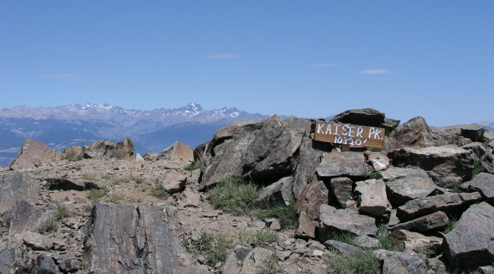
~1987 Kaiser Peak; My 1st Real Rock Climb
What I am about to relate really happened. I have no pictures to prove beyond the picture etched clearly in my head of when I encountered a burning bush on a mountain that was not consumed. It happened in this wise.
As a family we always pray for each other and safety. We cannot tell when, in God’s wisdom, He may or may not intervene, but we always invite. This morning would not have been an exception as our two families set about for an adventure in the High Sierras. What my partner Chuck Miller and I ended up climbing was not the actual peak but a super inviting face near the main peak with excellent dihedrals, what turned out to be a life challenging roof and more.
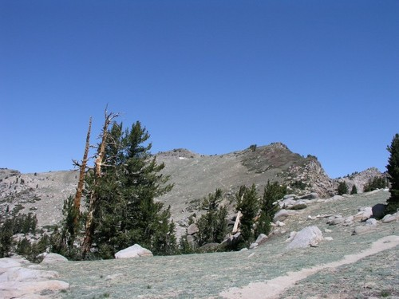
Chuck and I had great ambitions of summiting the actual peak via a face/crack system and for some crazy reason decided to make the day a family affair.
We were working our way up the trail with our entourage of women and small children (youngest like 1 year!) when we came across a dude ranch. The young gal running the place at that time advised us, “Kaiser Peak?” scanning our crew… “You’ll never make it with these!, but tell you what – for $50 a horse, you and the kids can ride double and we can get you up in striking distance of the peak.” “Deal!”
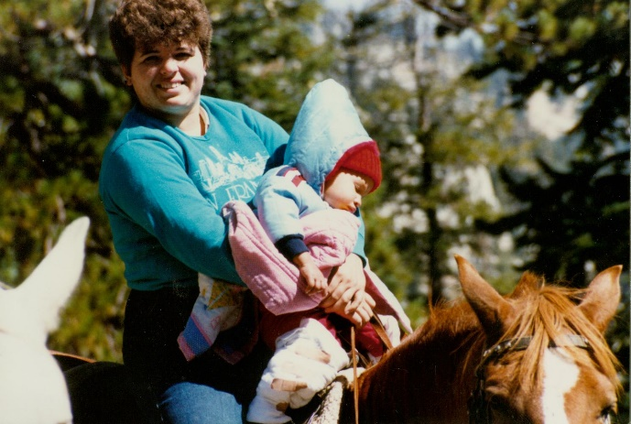
So our adventure was just getting better by the mile! After an hour or so we arrived at a 10,000 foot saddle looking at the peak. The cool cool wind was just howling and wee Jordon, the 1-year-old (maybe younger) with bare legs was tuning the wrong color! We had cloth diapers and so we fashioned leggings for him with Band-Aids to tie them around his little legs, but two things were quickly obvious. The peak would take way more time than we had in the day and we had already spent too much time for out little ones wellbeing at this place. The other thing obvious was that the family had to retreat to warmer clime. So Jean took Jordon, and our 3-year-old Jared rode double with the nice lady wrangler. I think Judy’s young Natalie was old enough to ride her own mount and younger Chase rode double with Judy. We bid them well and spying a 300-foot face with wonderful features, we settled on this new challenge as our day’s reward.
Now for background, it should be understood that I was a total newbee taking up Chuck's invite to learn climbing – for me an opportunity to overcome my intense fear of heights. We done some little stuff and up til now it was all safely top-roped for me. This would be the real deal.
Chuck led out up the face with a vertical crack suitable to use our system of protection; mostly wedges, hexes and the like. I think we had two of the new-fangled camming “friends” between us. The climb was technically easy for me – maybe a 5.8 – nothing crazy and as I followed I collected the pro’ Chuck had placed and racked it up on my harness. Arriving at a narrow ledge where Chuck was perched, I think I must have looked at him with a “OK what’s next” look and he just waved me on – “Keep going” “HUH???? What do you mean? I don’t know how to lead - how to place pro’ !” “Ah, You’ll do fine,” he dismissed, “besides everyone takes his share of the risks, It’s your turn and you have all the gear. You’re an engineer. You got this!”
Gees, Im thinking, well if he has confidence in me, I’ll do it, so off I went picking out a dihedral (open book) that I could hand jam my way nearly straight up the face. I was always more comfortable jamming than using the little scrawny finger pinch moves out in the open! So up up I went a good hundred feet or more and then I encountered one of those challenges that involves God! Let me explain.

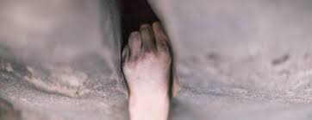
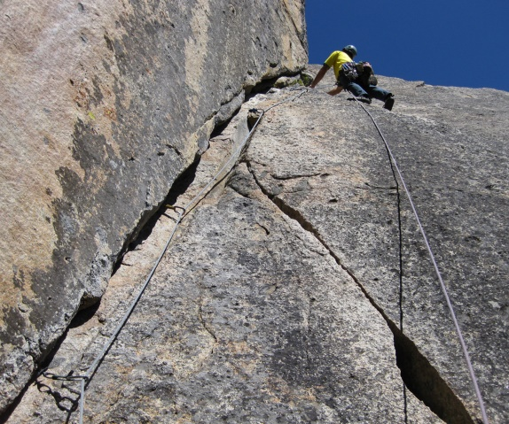
I love the mountains and the challenge, but I’m not really an adrenaline junky. Not at all. That part I tolerate to get close and intimate with God’s creations and do so sometimes close in to my ultimate physical limits. In this case I was looking at my edge; while verily - on the edge. There was about a 6-foot roof and a crack system to work – I’d be almost hand over hand hanging from a jam to navigate this. Adding in rope stretch and slack of several feet, the thought of falling even 10-15 feet was most unpleasant as it would be a swinging pendulum slam to the dihedral below. Folks die from that sort of head bang. A freefall to a hang would be sooo much more pleasant and survivable, but this is what I had to deal with and there was no getting off this ride!
I placed 3 pro’ in the corner of the roof and started out. My youthful arms were totally pumped and my lean body (those days - more so) was working the problem like choreography. This was sweet.
I got to the edge of the roof, found a one inch ledge for my left foot and pulled myself up and onto the face above just a bit. My right foot was pawing at a smooth unbroken granite vertical slab. Above me the crack abruptly widened then narrowed but just out of reach. I used a trick called an arm lock where I jammed my whole elbow and forearm into the off-width crack. And then I struggled again and again to reach that next jam. If you are wondering what I mean by a jam; there are no holds to grab, just a crack that you thrust (and trust) your body part into, flexing twisting or camming to make it big enough not to pull out. If you put enough pressure most of your skin stays on!
But try as I might I could not reach past the off width section. I examined the rock for any imperfection, ridge, nothing smooth as a polished granite table top. And that leg on the 1” ledge holding much of my weight was starting to sewing machine, a sure sign of eminent system collapse – I hope we wore helmets in those early days– I think so, but I had read of many climbing accidents that the pendulum smack had killed many so protected – I hollered to Chuck way below that there was a good chance I would peel and to “take” up the slack. It did not look good…
So in those moments, when I’m trying to get close to God’s handiwork, the obvious next last step is to petition the maker, because – did I mention, It didn’t look good; perhaps even survival was at serious question. So I asked, “Lord, there is a decent chance if I fall here, I’m going to die. If that’s not the plan, I could use your help right about now as I cannot last more than a few moments longer hanging like this….”
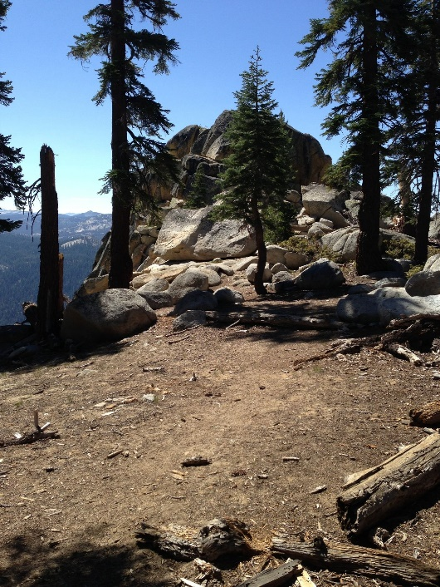
No sooner had I uttered that petition, but that my attention was drawn to a rectangular crack about hip height in that smooth granite face that facing outward my ineffectual right leg was pawing on. I have to tell you my 1st thought was, “No way! Where did that come from?” My second thought was – “that’s one for the books, I’ve seen lots of cracks but never a rectangular one the shape of a building brick.” My 3rd thought was – “dude you did just ask! Try it!” So with my free right hand I palmed the face and to my utter astonishment the face of the granite subscribed by the crack moved – “Oh Lord!” I gasped! I wiggled it and out popped a nearly rectangular brick of granite leaving a perfect foothold in the face. I let the rock fly and counted the several seconds to impact far below. My whole body was nearly a quivering wreck and my right leg had not the strength to lift up that high but I caught my pant leg with that free hand and pulled my leg up into the hole, pressing my knee. The extra couple feet of that solid perch was just the ticket to put me in reach for a fist jam and off I went – in just a few more moves I stood on top of a massive granite cactus leaf overlooking a sacred place where God spoke and reached my reaching. I suppose he had more for me to do.
I brought Chuck up to where I sat stunned by my fortune and blessing and whole grandeur of the moment, but I was done leading for the day, my 1st day doing a real serious rock climb, but just another day in my sojourn with God.

